System Design is the process of defining the architecture, components, and interactions of a system to satisfy specified requirements.
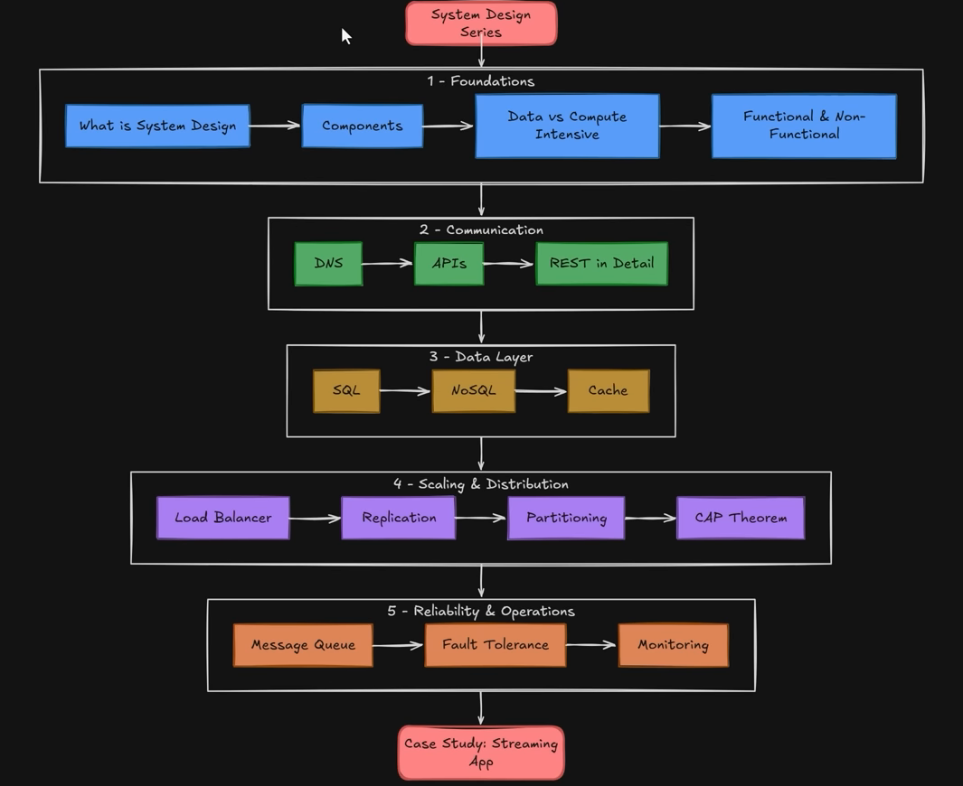
System = Components + Common Goal

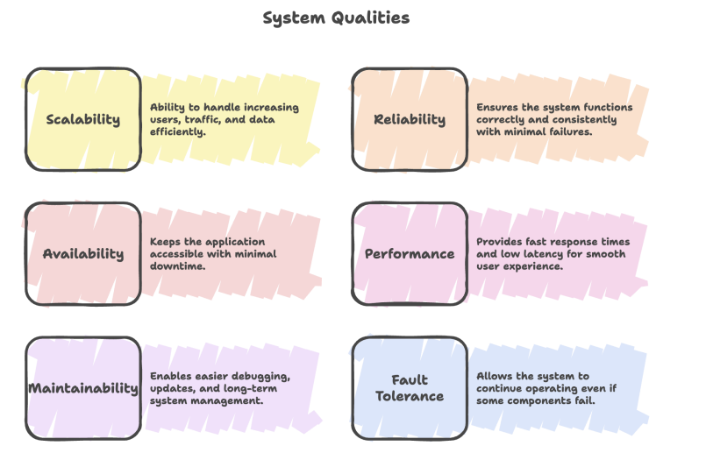

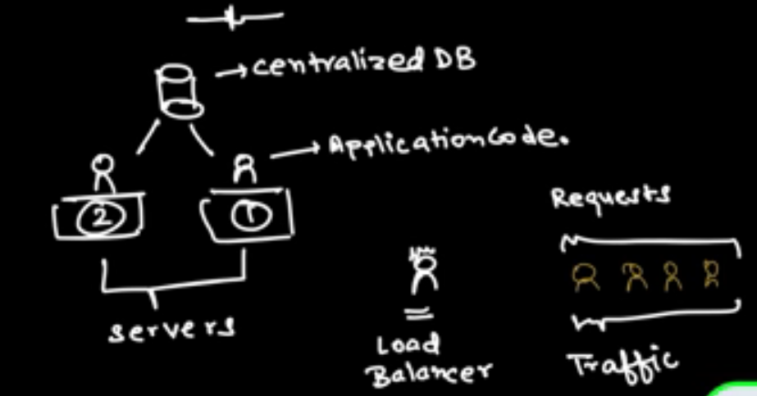

Key Takeaways
● Optimizing internal processing improves system performance (LLD).
● Vertical scaling increases the capacity of a single server.
● Horizontal scaling increases capacity by adding more servers.
● Centralized databases help maintain data consistency.
● Load balancers distribute traffic efficiently across servers.
● A good system should be scalable, reliable, maintainable, efficient, and fault-tolerant.

System Design Components
- Database
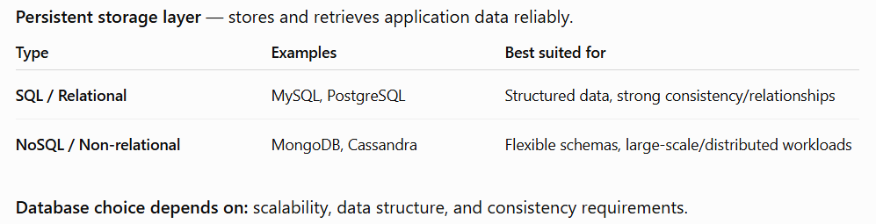
- Backend / Application Server
Acts as the middle layer between client and database.
- Exposes APIs
- Handles CRUD operations and Processes client requests
- Communicates with databases
- Hides database implementation/details from clients
Backend ↔ Database communication: Uses network addressing such as IP and protocols such as TCP/HTTP.
JSON (JavaScript Object Notation) is the common format for API data exchange.
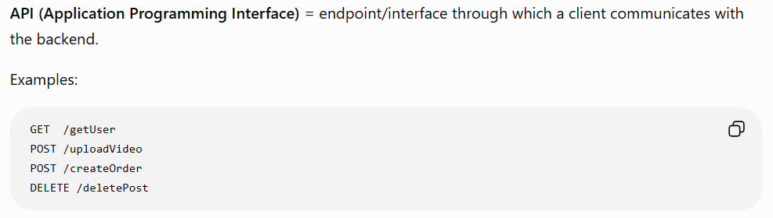
- Client Application / Frontend- The user-facing layer of the system
Responsibilities: Display data, collect user input, send requests to backend APIs, display server responses.

- Cache- A fast-access storage layer containing frequently accessed data.
Benefits:
  - Reduces database queries and load.
  - Improves response time.
  - Improves overall performance

- Load Balancer- Distributes incoming requests across multiple backend servers.
Users → Load Balancer → Server 1 / Server 2 / Server 3
  - Prevents one server from becoming overloaded by enabling horizontal scaling.
  - Performs health checks, Improves availability/reliability and resource utilization.

- Message Queue- Enables asynchronous communication between services.
Instead of making one service wait for another:
Service A → Queue → Service B
Benefits:
  - Decouples services
  - Handles traffic spikes
  - Improves responsiveness and Provides reliability through retries
  - Allows independent processing
Synchronous vs Asynchronous
Synchronous- Caller waits for response. Used when the result is immediately required.
- Example: payment confirmation before completing an order.
Asynchronous- Caller continues without waiting. Used for tasks in the background.
- Example: sending email/SMS after an order.
- Monitoring & Logs
Monitoring- Tracks system health, performance, and resource usage. Used for alerts and detecting problems.
Logs- Record application events/errors. Useful for debugging and troubleshooting.

Benefits:
  - Detect application errors
  - Check whether traffic is distributed correctly
  - Investigate failures using stack traces
  - Reproduce production issues
  - Verify new deployments haven't broken existing functionality
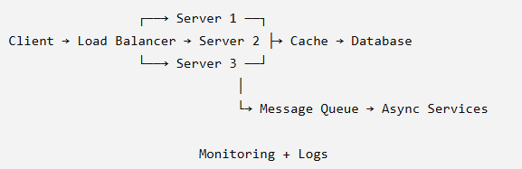
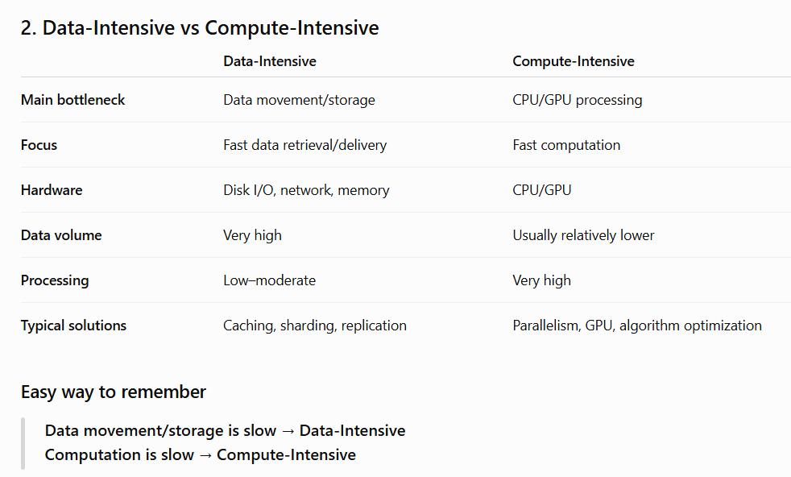
Latency = time taken by a system to respond to a request. Lower latency, faster response.

Data - Intensive vs Compute – Intensive Applications
1. Data-Intensive Applications
Applications where the main challenge is storing, retrieving, transferring, and serving large amounts of data efficiently.
Examples: Instagram feed, Banking systems
Main challenges
- Slow database queries
- Large network transfers
- Insufficient server/storage resources
Common solutions
- Caching → faster access to frequently used data
- Sharding → distribute data/load across multiple DBs
- Replication → maintain copies for availability/fault tolerance
- Consistency models → control correctness across distributed copies
- DB optimization → indexing, query optimization, appropriate DB choice

2. Compute-Intensive Applications
Applications where the primary bottleneck is CPU/GPU computation.
Examples: Image processing, Video rendering/encoding, ML model training
Common solutions
- Parallel processing → execute independent tasks simultaneously
- GPU acceleration → massively parallel computations
- Distributed computing → spread computation across machines
- Algorithm optimization → reduce time/space complexity

3. Modern Applications Can Be Both
YouTube
- Data-intensive → video storage, streaming, retrieval
- Compute-intensive → recommendations, personalization, analytics
Rule of Thumb- Where is the time being spent?
Moving/storing data → Data-Intensive
Processing/calculating data → Compute-Intensive
Functional vs Non-Functional Requirements
Every software system is built around two important types of requirements:
● Functional Requirements – Define WHAT the system should do.
— features, user actions, and business logic.
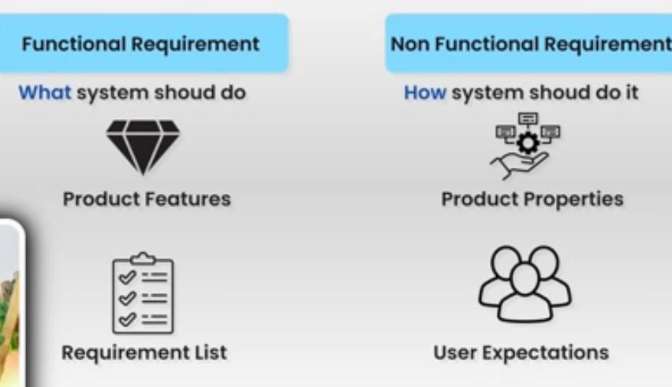
E-commerce examples:
Register / Login, Browse products
Search / Filter products, add to cart, Apply coupons
Place orders, Make payments, Track orders
Why important?
- Defines what needs to be built
- Helps identify required APIs
- Helps determine database operations
- Defines business logic/user interactions

● Non-Functional Requirements – Define HOW WELL the system should perform.
- system quality, performance, scalability, reliability, and constraints.
Examples: Support 1M concurrent users
- Response time < 200 ms, 99.9% availability
- Data encryption, Handle 10× traffic, Fault tolerance
Key Non-Functional Attributes
- Scalability- Ability to handle increasing traffic/workload.
- Vertical scaling (scale up): increase CPU/RAM/etc. of an existing server.
- Horizontal scaling (scale out): add more servers.
Generally: horizontal scaling is preferred for large distributed systems.
2. Availability- How often the system remains operational and accessible.
Expressed as uptime %:
- SLA (Service Level Agreement): contractual commitment to availability/performance.
- SLO (Service Level Objective): target reliability/performance level.
3. Reliability- Ability to continue functioning correctly and avoid data loss, even when failures occur.
Availability ≠ Reliability
- Availability → Is the system accessible?
- Reliability → Does it continue to work correctly?
4. Performance / Latency- Measures how quickly requests are processed.
Example: P99 = 200 ms means 99% of requests take ≤ 200 ms; the slowest 1% take longer.
5. Security- Protects users, systems, and data.
- Authentication: Who are you?
- Authorization: What are you allowed to do?
- Encryption: Protect data during transmission and storage.
6. Maintainability- How easily the system can be modified, updated, debugged, and extended.
7. Observability- Ability to understand the internal state of a system from its external outputs.
Main pillars/tools:
- Monitoring → system health/metrics
- Logging → events/errors
DNS — Domain Name System
Key Terminology
- Domain: Human-readable website address. Example: telusko.com
- Subdomain: Domain under a parent domain. Example: docs.telusko.com
- IP Address: Numerical identifier of a device/server on a network. Example: 192.168.1.1
DNS translates domain names → IP addresses.
Example: telusko.com → 142.x.x.x
Think of DNS as the "phonebook of the Internet."
Without DNS, users would need to remember IP addresses for every website.
It also handles changing IP addresses caused by:
- Server migrations, Cloud deployments, Infrastructure changes, Load balancing
Browsers cannot maintain mappings for hundreds of millions of domains.

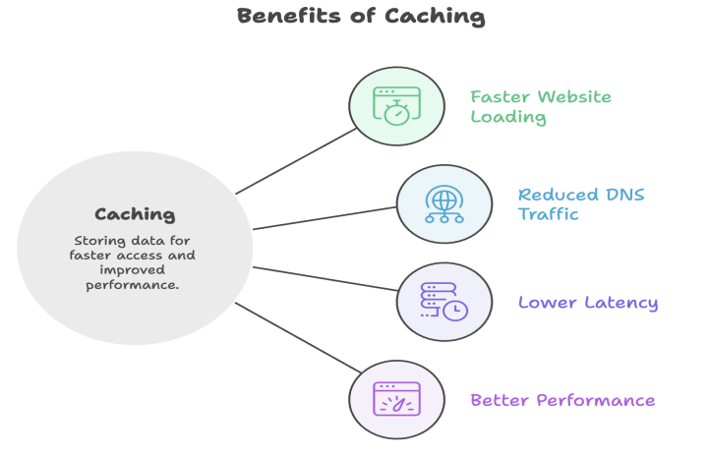
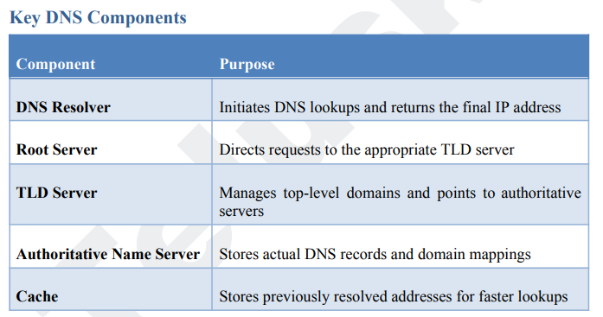
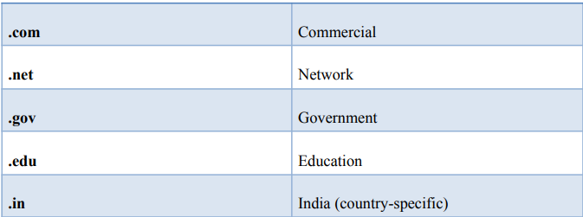
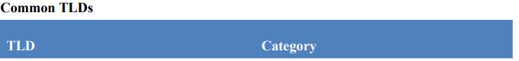
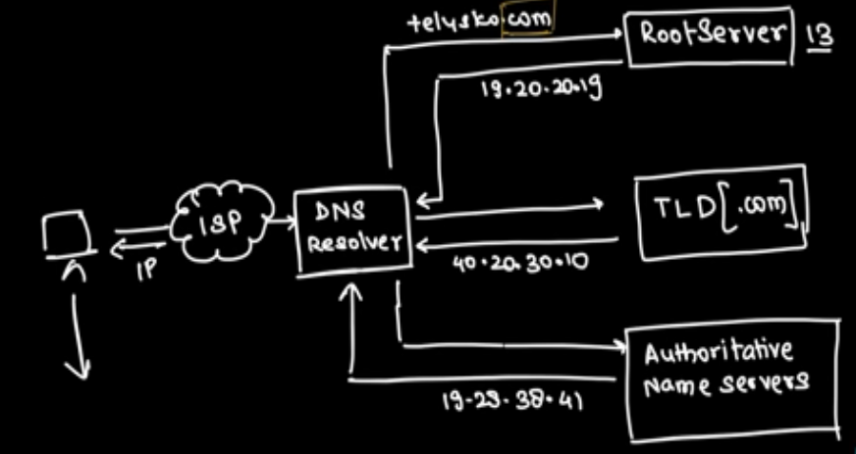
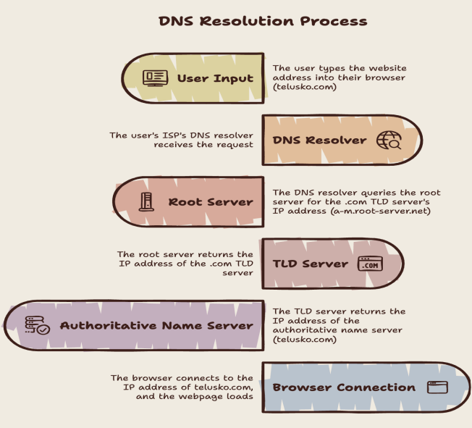

DNS Caching- Full DNS resolution for every request is slow, so DNS responses are cached.
Cache Levels
- Browser Cache- Stores recently resolved domains. Example: telusko.com → IP
- OS Cache- Operating system maintains previously resolved DNS records.
- DNS Resolver Cache- Resolver/ISP caches frequently requested domains. Shared across its users.
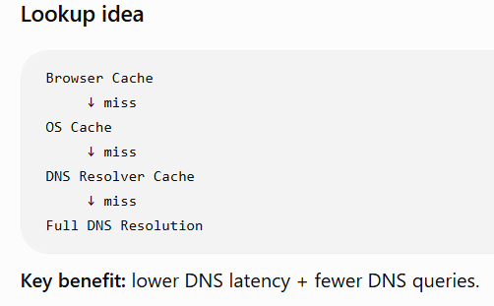
DNS Zones & Subdomains
An Authoritative Name Server manages one or more DNS Zones.
A zone contains DNS records for a particular domain and its managed subdomains.
Example:
Zone: telusko.com
telusko.com → 93.184.216.34
docs.telusko.com → 93.184.216.35
courses.telusko.com → 93.184.216.36

REST API Requests
REST (Representational State Transfer) is an architectural style for designing web services/APIs.
REST enables client ↔ server communication over HTTP using:
- Resource-based URLs
- HTTP methods
- Usually JSON for data exchange
JSON (JavaScript Object Notation) is a lightweight, language-independent format for exchanging data between client and server.
Uses Key-value pairs, Objects, Arrays, Multiple data types (string, number, Boolean, null, etc.)
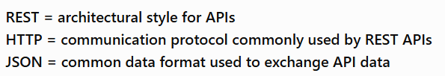
Anatomy of a REST Endpoint
An endpoint is a URL through which an API can be accessed.
Every REST endpoint consists of two parts:
Endpoint = HTTP Method + Resource Path
METHOD /resource -> Example: GET /users
Components of a REST API Request
1. HTTP Method- defines the action that should be performed on a resource.
2. Resource Path (URL)- The path identifies the resource that the client wants to access. /users
3. Headers- provide additional information (metadata) about the request.
4. Request Body- Actual data sent to the server. It is commonly used with: POST, PUT, PATCH.
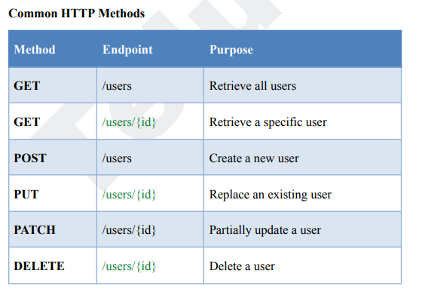

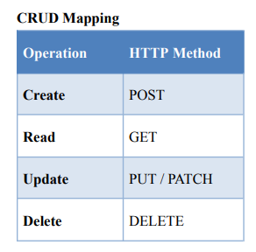

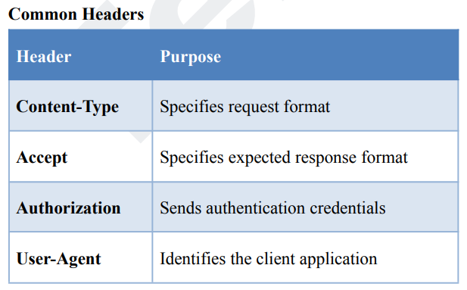
PUT vs PATCH
1. PUT – Full Resource Replacement
If some fields are not included in the request, they may be overwritten with default or null values.
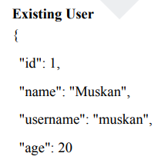} 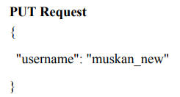 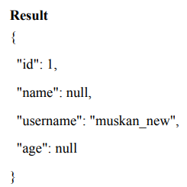
Use PUT when you want to replace the complete resource with a new version.

2. PATCH – Partial Resource Update
PATCH updates only the specified fields. All other fields remain unchanged.
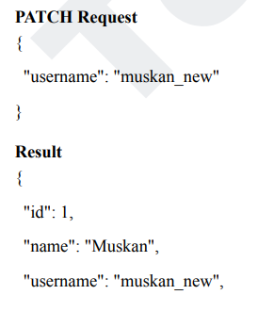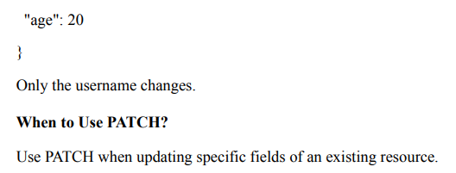
Ways to Pass Data in REST APIs
REST APIs support three primary ways of sending data-
1. Path Parameters- Used for resource identifiers.
Example /users/42
Here, 42 is a path parameter.
Use Cases- User IDs, Product IDs, Order IDs.
2. Query Parameters- Used for filtering, sorting, and pagination.
Example /users?age=20&sort=name
Common Uses- Filtering records, Sorting results, Searching, Pagination.
3. Request Body- Used when sending complex or sensitive data.
Example { "username": "muskan", "password": "********" }
The request body is the preferred location for large payloads and confidential information.
Path parameters and query parameters are visible in the URL. Request Body provides better security and privacy.
REST API Response
When a client sends a request, the server processes it and returns a response.
The response tells the client:
- Whether the request succeeded or error occurred
- What data to display/process
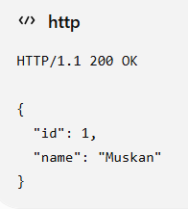
Main Parts of a REST Response
1. HTTP Status Code- Numeric code indicating the outcome of the request.
2. Response Body- Actual data returned by the server. Usually in JSON.

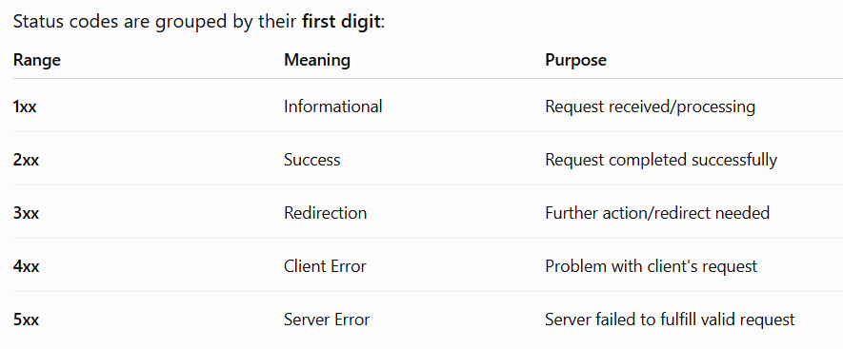
2xx
- 200 OK → successful request
Used when data is successfully retrieved. Get/users/1
- 201 Created → resource successfully created
Used when a new resource is successfully created. POST /users
- 204 No Content → successful, but no response body
Used when the operation succeeds but nothing has to return. DELETE/users/1
3xx
- 301- Permanent Redirect- Resource permanently moved
- 302- Temporary Redirect- Resource temporarily moved
4xx
- 400 Bad Request → invalid request
- 401 Unauthorized → authentication required/failed
- 403 Forbidden → authenticated but not permitted
- 404 Not Found → resource doesn't exist
- 409 Conflict → request conflicts with current state
5xx
- 500 Internal Server Error → unexpected server error
- 502 Bad Gateway → gateway/proxy received an invalid response
- 503 Service Unavailable → server temporarily unavailable

REST Response Bodies
Contains the actual data returned by the API, usually as JSON.
Common forms:
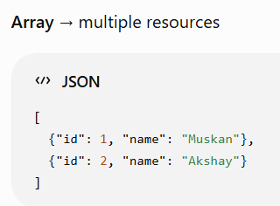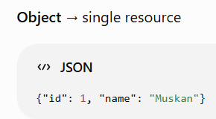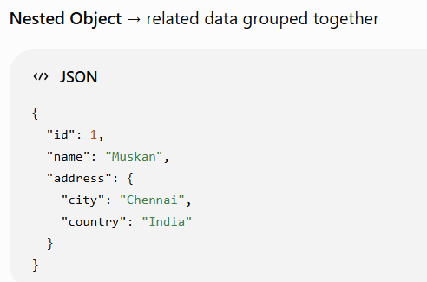
Prefer Object-Wrapped Responses
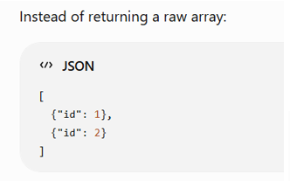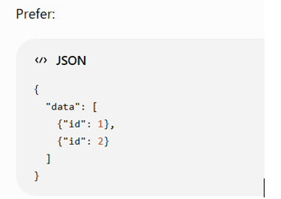
Benefits of Object-Wrapped Responses
1. Easy Extensibility- Additional information can be added without changing the structure.
2. Supports Pagination- Useful when returning large datasets.
3. Supports Metadata- Additional information can be included.
4. Supports Error Information.
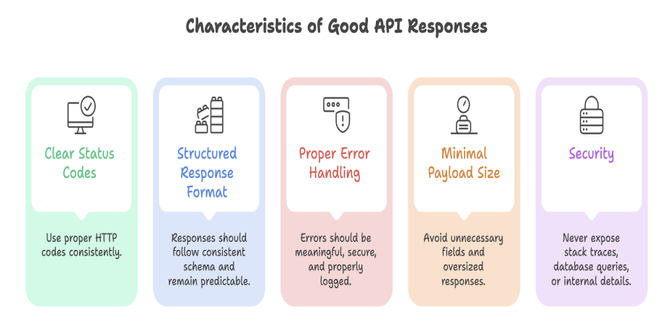

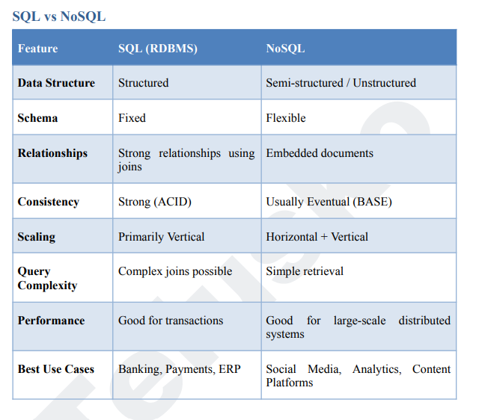
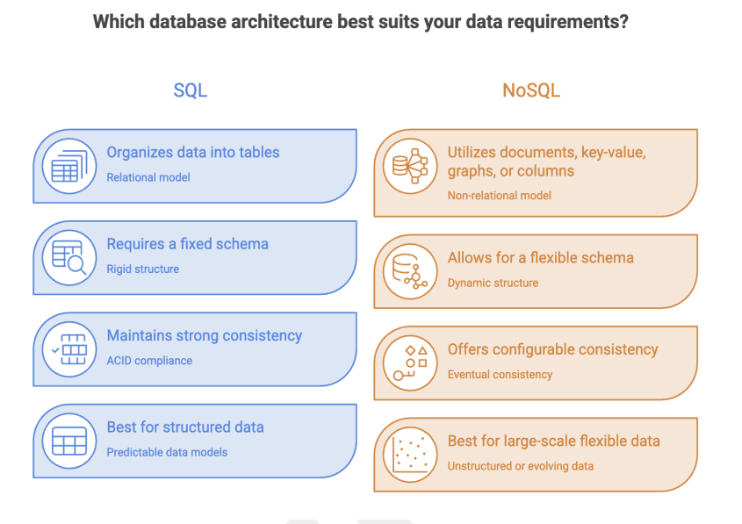
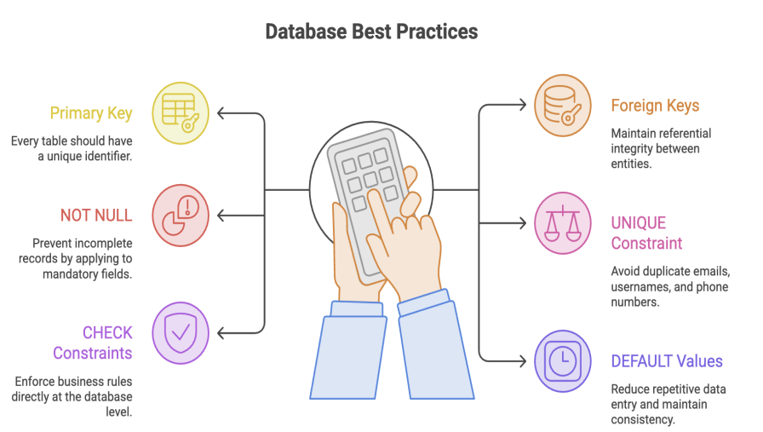
Database constraints are rules that ensure data integrity, consistency, and reliability with relational databases.
- PRIMARY KEY uniquely identifies each record.
- FOREIGN KEY establishes relationships between tables and maintains referential integrity.
- NOT NULL guarantees that mandatory fields always contain values.
- UNIQUE prevents duplicate values in important columns such as emails and usernames.
- CHECK validates data against business rules before storage.
- DEFAULT automatically assigns predefined values when none are provided.
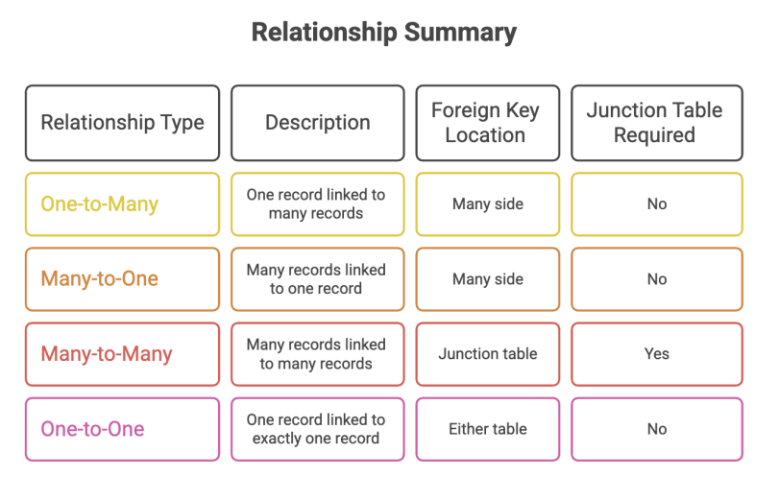
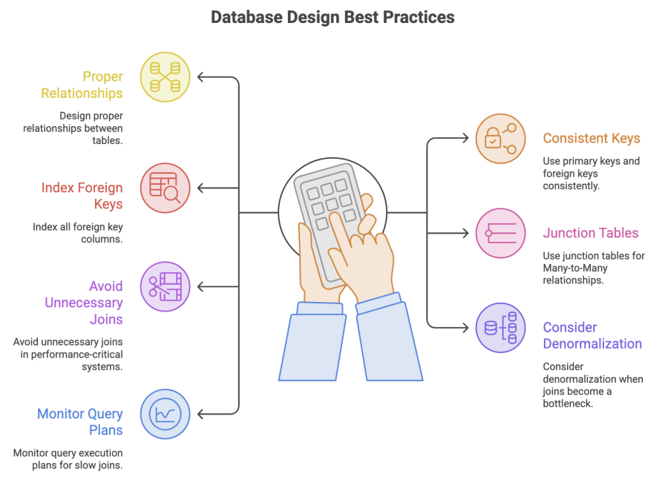

Database Scaling Approaches
Databases can be scaled in two primary ways.
1. Vertical Scaling: means increasing the capacity of a single server.
Examples:
- More RAM
- Faster CPU
- Larger storage
- Better hardware
Advantages
- Simple to implement
- No major application changes
Limitations
- Expensive
- Physical hardware limits exist
- Eventually reaches a maximum capacity
2. Horizontal Scaling: means distributing data across multiple servers. The workload is distributed among all servers.
Examples- Instead of one server: Server 1, Server 2, Server 3, Server 4
Advantages
- Nearly unlimited scalability
- Better fault tolerance
- Improved availability
Challenges in SQL Databases
- When data is distributed across multiple servers:
  - Joins become complex
  - Foreign key relationships become difficult to maintain
  - Cross-server queries become slower
This is one of the major reasons why NoSQL databases became popular.
Common Techniques
● Sharding: Data divided into smaller partitions and distributed across multiple servers.
● Replication: Copies of data are stored on multiple servers to improve reliability.

NoSQL databases were created to solve scalability and flexibility challenges faced by traditional relational databases.
- They store data in formats such as documents, key-value pairs, wide columns, and graphs.
- NoSQL databases are designed for horizontal scaling and distributed architectures.
- They provide flexible schemas, making them ideal for rapidly changing applications.
- NoSQL databases reduce the need for joins by storing related information together.
- SQL is preferred when strong consistency and complex relationships are required.
Types of NoSQL Databases
NoSQL databases are generally classified into four major categories:
1. Key-Value Databases
2. Columnar Databases
3. Graph Databases
4. Document Databases
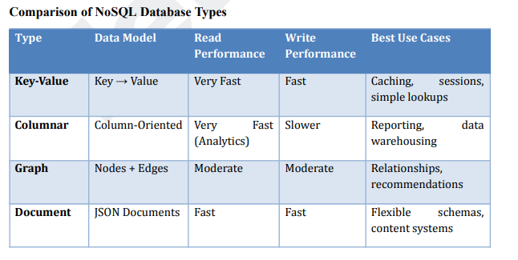
  - Key-value databases provide extremely fast access and are ideal for caching and session management.
  - Columnar databases are optimized for analytical workloads and large-scale reporting systems.
  - Graph databases excel at managing and analysing relationships between interconnected entities.
  - Document databases offer schema flexibility and are widely used for content platforms, user profiles, and modern web applications.

Cache
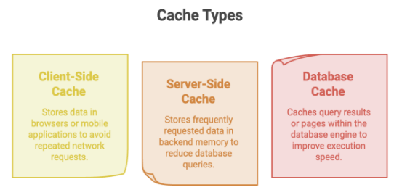
TTL — Time to Live- How long a cache entry remains valid. After TTL expires, the entry is evicted/invalidated, helping prevent stale data and freeing memory.
Cache generally stores: Key → Value (+ metadata such as TTL)
Caching Strategies
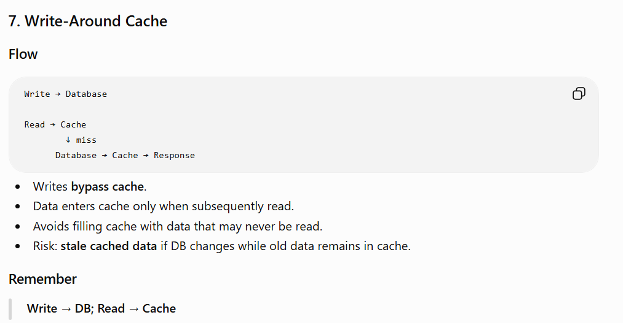
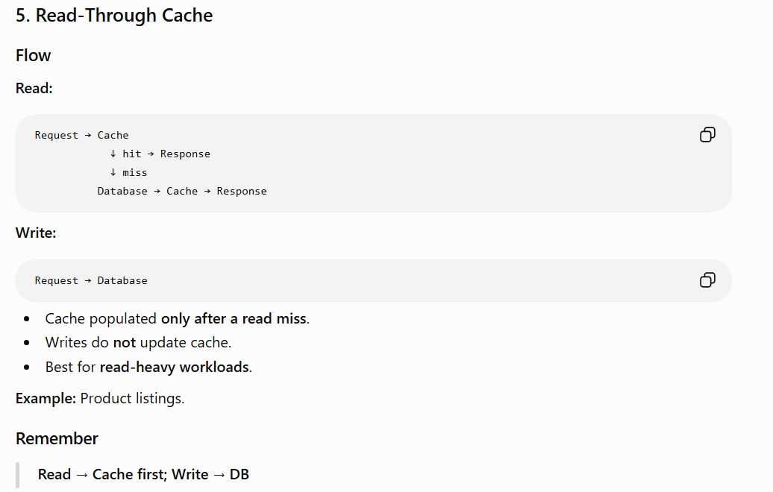
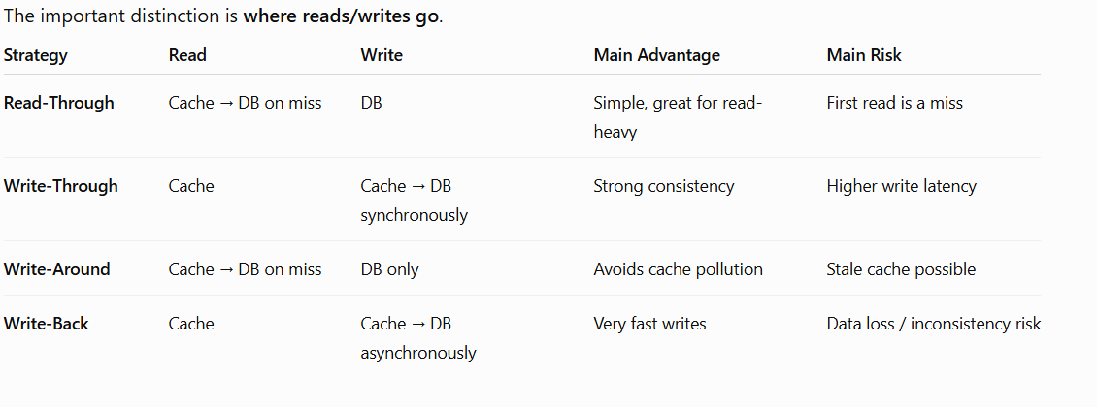
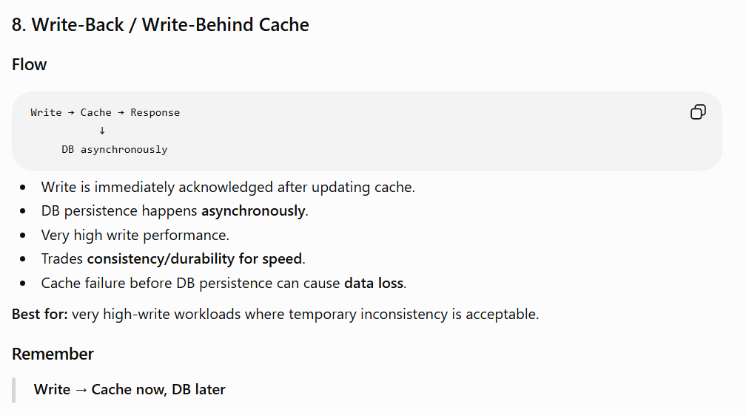
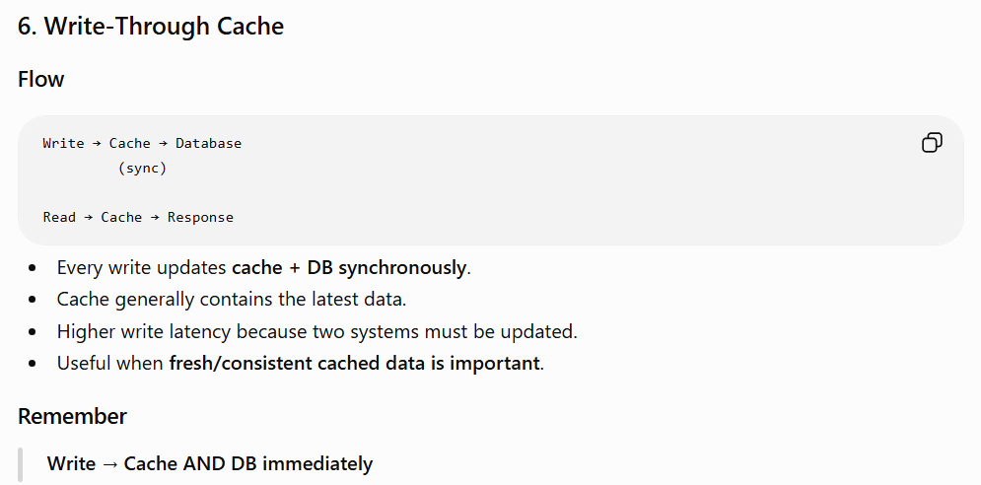
Cache Eviction Policies-> LRU, MRU, LFU, FIFO, LIFO.
Load Balancer
A Load Balancer (LB) distributes incoming requests across multiple backend servers.
Main responsibilities
- Server selection → decide which server handles each request.
- Health checks → detect unhealthy servers and stop routing traffic to them.
Benefits
- Scalability → distribute traffic across servers
- Availability → route away from failed servers
- Fault tolerance
- Better overall performance
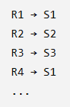
Load Balancing Algorithms
1. Round Robin- Requests are distributed sequentially:
Pros: Simple, equal distribution.
Cons: Doesn't consider server capacity or current workload.
Use when servers have roughly equal capacity.
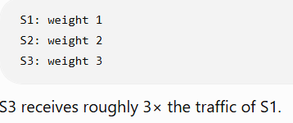
2. Weighted Round Robin- Each server gets a weight based on capacity.
Pros: Handles heterogeneous servers.
Cons: Still doesn't dynamically account for current workload.
Higher capacity → higher weight → more requests
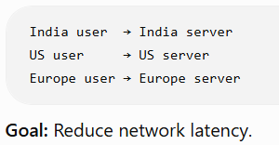
3. Geo-Based- Routes users to a geographically nearby server/region.
Requires:
- Infrastructure across regions
- Data replication across regions
- Regional failover
Challenge: VPNs/proxies can make location detection inaccurate.
4. Least Connections- Routes the request to the server with the fewest active connections.
Pros: Better than Round Robin when request durations vary.
Cons: Connection count doesn't necessarily represent CPU/processing load.
Fewest active connections → selected server
5. Least Time- Routes requests to the server with the lowest response time.
Considers: Number of requests and Average response time
Pros: Useful for latency-sensitive systems.
Cons: Requires continuous performance measurement.
Lowest response time → selected server
6. IP Hash- Hashes the client's IP to determine the server.
Client IP → Hash → Server
Same client IP generally maps to the same server, providing session persistence (sticky sessions).
Pros: Useful when sessions are tied to a server.
Cons:
- Adding/removing servers can cause many mappings to change with naive hashing.
- Uneven distribution is possible.
- IP-based affinity can break with proxies/NAT.
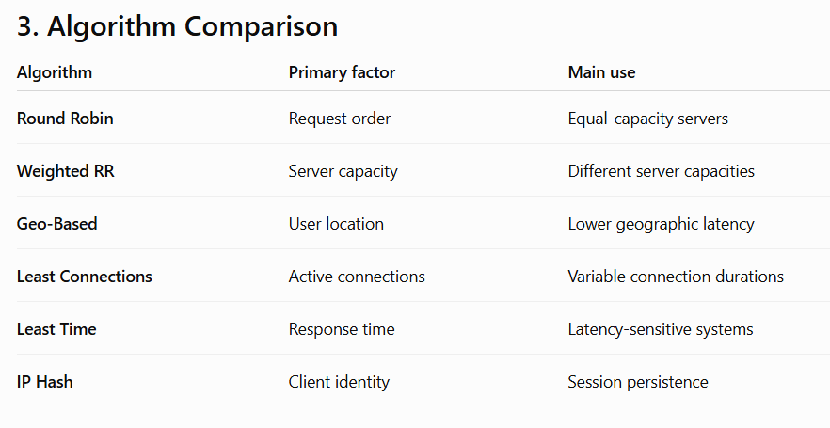
For modern systems, consistent hashing is often preferred when stable mappings during scaling are important.
Real systems can combine strategies depending on requirements.
Example:
Geo-based routing → regional LB → Least Connections → backend servers
This can optimize:
- Geographic latency, Server utilization, Availability

Load Balancer Health Checks
A Load Balancer uses health checks to determine whether backend servers are healthy enough to receive traffic.
- Detect unhealthy/degraded servers
- Stop sending traffic to failed/slow servers
- Improve availability and reliability

Types of Health Checks
- Passive Health Check- Uses real production traffic to infer server health.
- No additional probe requests
- Monitors response time, failures, error rates
- Low overhead and Reflects actual workload
Real traffic → observe response → determine health

- Active Health Check- LB periodically sends dedicated probe requests to servers.
- Regular health-check requests
- Faster/more explicit health detection
- Small additional traffic/overhead
Probe → server → response → determine health
Health Check Parameters
1. Interval- How frequently checks are performed. Example: every 5 seconds
2. Timeout- Maximum time to wait for a server's response. If response exceeds timeout → failed check.
3. Threshold- Number of consecutive successes/failures required before changing health status.
Example:
- 3 consecutive failures → mark Unhealthy
- 2 consecutive successes → mark Healthy

Health Check Workflow
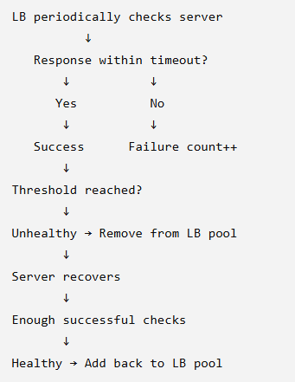
Replication
Maintaining multiple copies of the same data across multiple nodes/databases.
- High availability
- Fault tolerance and Disaster recovery
- Read scalability
- Reduced latency when replicas are geographically closer

- Single-Leader Replication
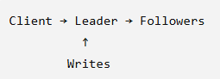
One node is the Leader/Primary; others are Followers/Replicas.
- Writes → Leader
- Reads → Leader or Followers (depending on consistency requirements)
- Asynchronous Replication
Leader responds without waiting for followers.
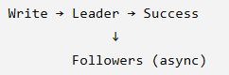
Pros- Low write latency. Leader isn't blocked waiting for replicas
Cons
- Followers can lag
- Recent writes may not be immediately visible on replicas
- Possible data loss if leader fails before replication completes
Use when: availability/latency is more important than immediate replica consistency.
- Synchronous Replication
Leader waits for required follower acknowledgments before confirming the write.
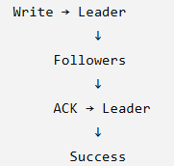
Pros
- Stronger consistency
- Replicas have the latest committed data
Cons
- Higher latency
- Write can be blocked if required replicas are unavailable
Async = faster, potentially stale replicas
Sync = stronger consistency, higher latency

Adding a New Follower
Typical process:
- Take a snapshot from leader/existing replica.
- Load snapshot into new follower.
- Start ongoing replication from the leader.

Leader Failure / Failover
If the leader fails:
- Detect leader failure.
- Choose an up-to-date follower.
- Promote it to leader.
- Inform/update other nodes about the new leader.
- Resume replication.
The exact election mechanism depends on the database/system.

Multi-Leader Replication
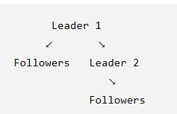
Multiple nodes/data centres can accept writes.
Leaders replicate with:
- Their own followers
- Other leaders
Advantages
- Higher write scalability
- Better availability across regions
- Regional/local writes can reduce latency
Major Problem: Write Conflicts
Example: Leader 1: name = "A", Leader 2: name = "B"
Both writes succeed → conflict when replicas synchronize.
Conflict Resolution
- Last Write Wins (LWW) → latest timestamp wins
- Leader Priority → preferred leader's value wins
- User Resolution → user chooses the correct value
Leaderless Replication
No designated leader. Multiple nodes can handle reads/writes.
A request succeeds when the required number of nodes acknowledge it.
Quorum
Let N = total replicas.
A common quorum setup requires:
- Read quorum R > N/2
- Write quorum W > N/2
This creates overlap between successful reads and writes.
More generally, systems can choose R and W based on desired consistency/availability.
Example: N = 3 W = 2 R = 2
A write needs 2 acknowledgments and a read contacts 2 nodes.
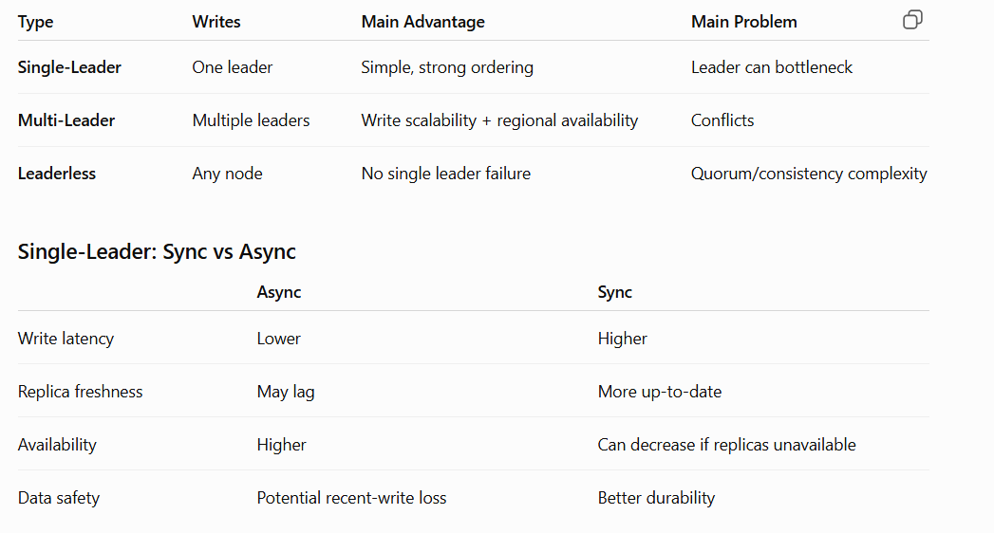

Partitioning
Splitting a large dataset into smaller chunks (partitions) and distributing them across multiple nodes.
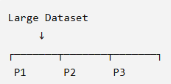
Together, all partitions represent the complete dataset.
Why partition?
- Massive datasets are expensive to replicate entirely.
- Query/search performance can degrade as data grows.
- Enables parallel processing. Improves scalability and throughput
Golden Rule
Distribute data AND traffic evenly across partitions.
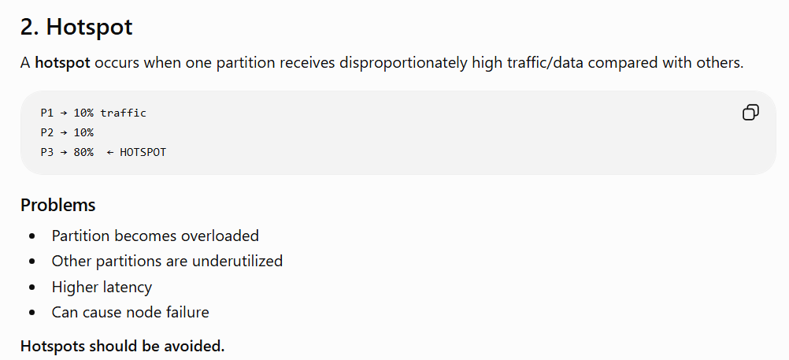
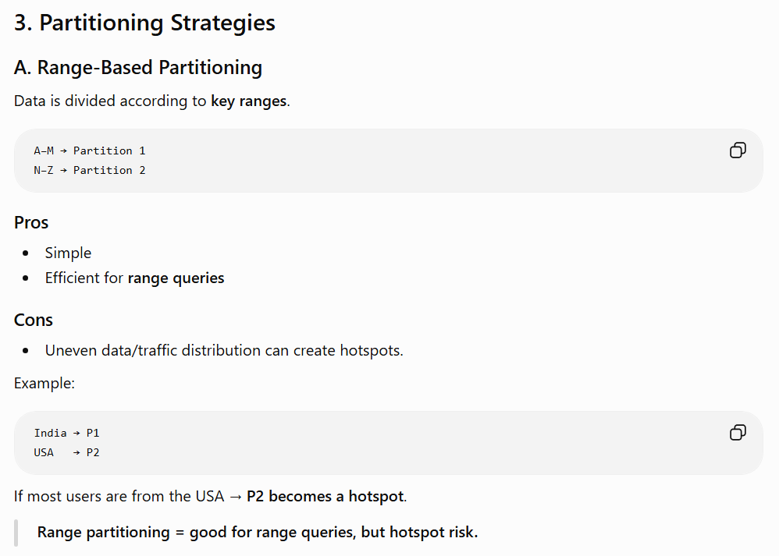
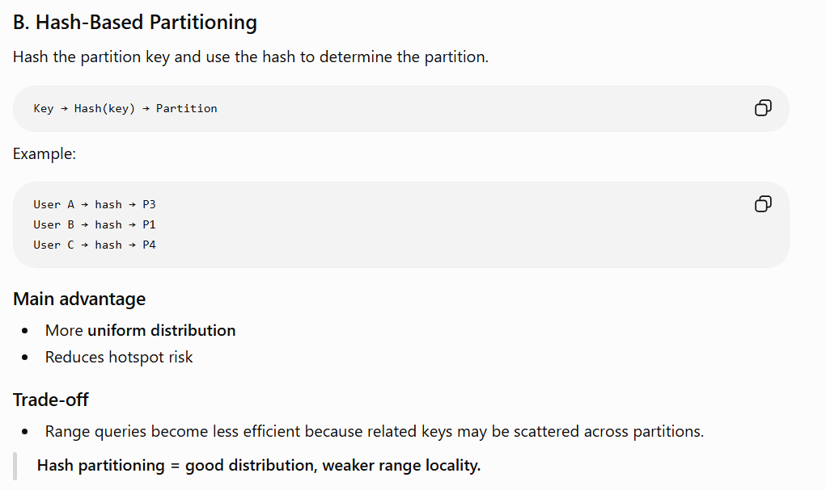
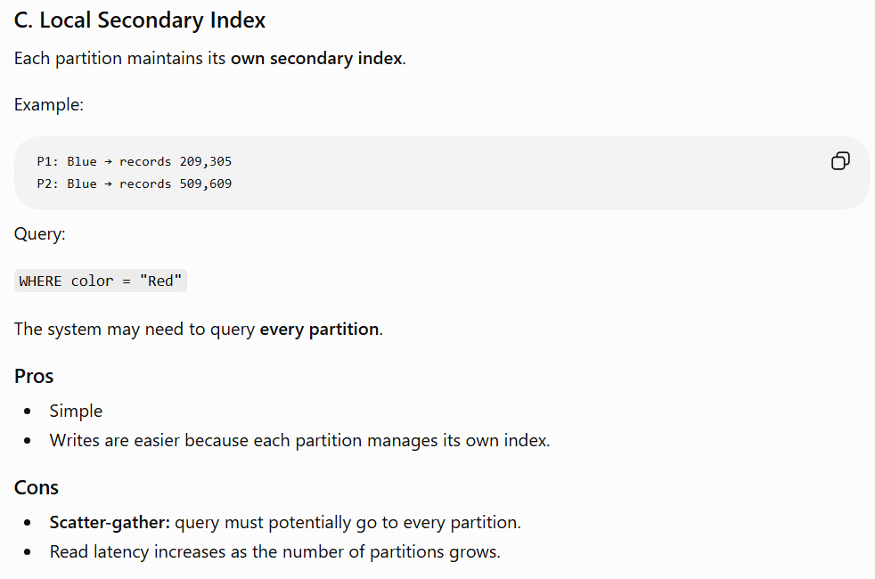
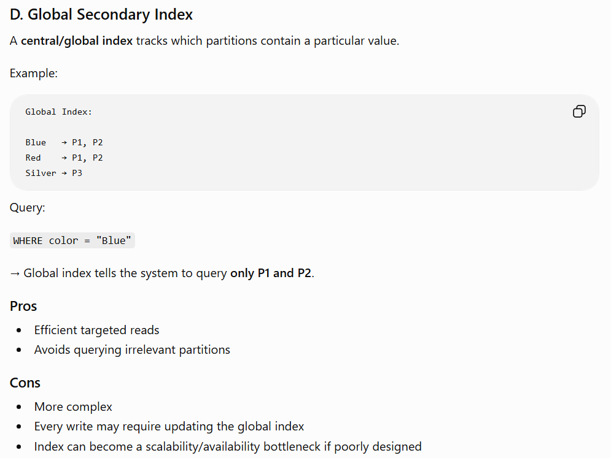
CAP Theorem
CAP Theorem: In a distributed system, during a network partition, you cannot guarantee both Consistency and Availability simultaneously.
The three properties:
Property | Meaning
C — Consistency | Every successful read gets the latest committed value
A — Availability | Every request receives a response, even if it may not be the latest data
P — Partition Tolerance | System continues operating despite network communication failures between nodes
In a truly distributed system, Partition Tolerance is generally required because network failures can happen. Therefore, the practical choice during a partition is:
CP vs AP
Suppose two replicas lose communication:
Client → Node 1 X Node 2 ← Client
Network Partition
Now a client writes new data to Node 1. Node 2 doesn't know about it yet.
If Node 2 responds immediately:
→ It may return old data
→ Availability maintained, Consistency sacrificed
If Node 2 refuses/waits until synchronization:
→ Latest data can be guaranteed
→ Consistency maintained, Availability sacrificed
Therefore, during a partition:
Choose Consistency OR Availability.
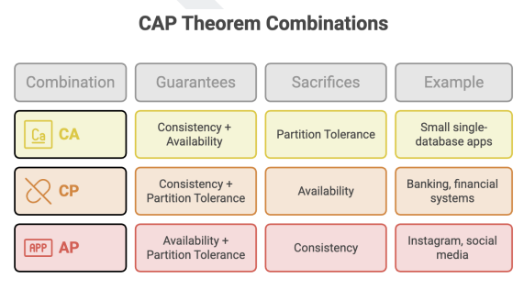
CAP is about behaviour during a network partition.
It does not mean a system is permanently either "consistent" or "available"; the trade-off becomes critical when communication between distributed nodes fails.
Message Queues
A message queue is a buffer between services that enables asynchronous communication.
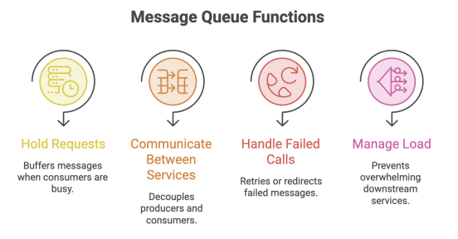
Producer → Message Queue → Consumer
Terminology
Term | Also called | Role
Producer | Publisher | Sends messages
Consumer | Subscriber | Processes messages

Required immediately → Sync
Can happen in background → Async

Message Processing
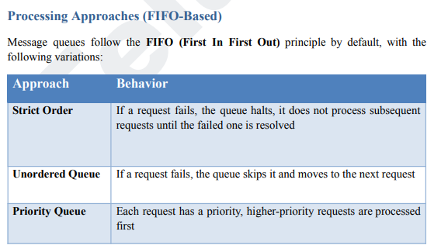
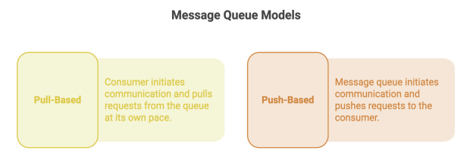
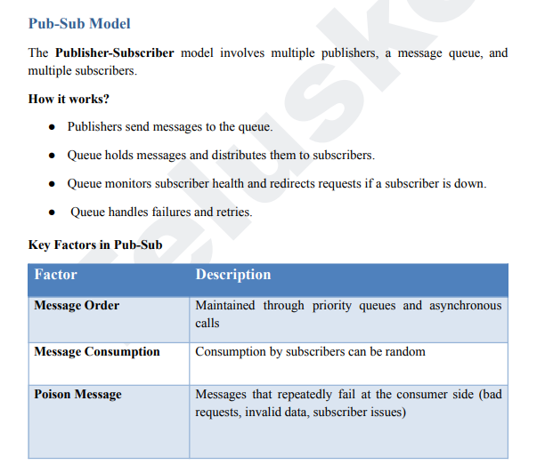

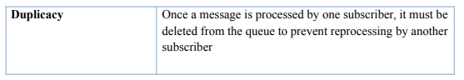

Dead Letter Queue (DLQ)
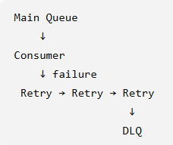
A Dead Letter Queue is a secondary queue maintained by the message queue to store messages that have failed processing after multiple attempts.
Purpose
- Isolate poison messages
- Prevent them from blocking normal messages
- Enable debugging/inspection
- Allow later retry/reprocessing
Why Use Message Queues?
Main benefits
Decoupling- Producer doesn't need to directly depend on consumer availability.
Traffic smoothing- Queue absorbs sudden traffic spikes.
Reliability- Messages can be retried if consumers fail.
Scalability- Add more consumers to process messages in parallel.
Asynchronous processing- Slow background work doesn't block the main request.

Common Use Cases
- Email/SMS/notifications, OTP delivery
- Analytics pipelines, Report generation
- Background jobs
- Event-driven services
- Deferred/scheduled processing
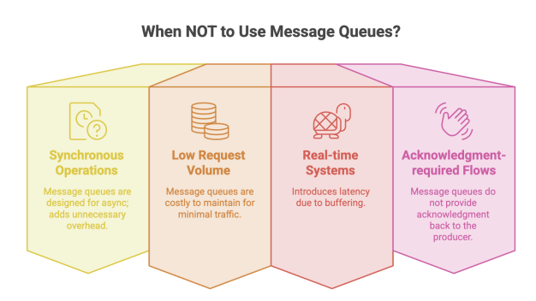
Faults & Errors
A fault/error occurs when a system deviates from its expected behaviour.
Faults can affect: Availability, Reliability, Performance, Data correctness
Types of Faults
A. Hardware Failures- Failures in physical infrastructure.
Examples:
- Disk crash/full disk
- Server failure, Network failure, Power failure
- Overheating, Hardware/database infrastructure failure
Characteristics:
- Often random/unpredictable
- Cannot always be prevented
Mitigation: Redundancy, Replication, Monitoring, Failover mechanisms
Hardware failure → redundancy + replication

B. Software Failures- Failures caused by application/software defects or configuration.
Examples:
- Bugs/bad code, Configuration errors
- Unhandled exceptions, Missing edge cases
- Deployment failures, Merge/integration problems
- Performance bottlenecks
Mitigation:
- Code reviews and Automated testing
- Exception handling
- CI/CD, Monitoring
- Safe deployment/rollback strategies
Software failure → testing + good engineering practices

C. Human Errors- Failures caused by incorrect human actions or decisions.
Examples:
- Incorrect configuration, Accidental deletion
- Deploying the wrong version , Incorrect operational commands
Characteristics:
- Difficult to completely eliminate
- Often highly unpredictable
Mitigation:
- Automation and Training
- Access controls / least privilege
- Standardized procedures
- Good UX/interfaces
- Approval mechanisms for risky operations
Human error → automate + restrict + validate
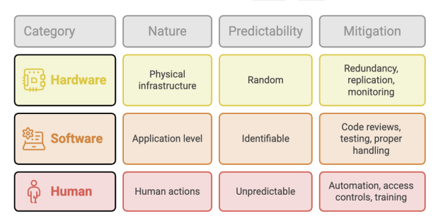
Monitoring vs Observability
Monitoring- Tracks predefined metrics, logs, and alerts to determine whether the system is within expected limits.
Monitoring = "Is something wrong?"
Examples: CPU utilization, Memory usage, API latency, Error rate, Server availability
Observability- Ability to understand the internal state of a system from its external outputs.
Observability = "Why is something wrong?"
Uses:
  - Metrics → numerical measurements
  - Logs → events/errors
  - Traces → follow a request across services
API Monitoring
APIs are the main communication layer between services, so monitor:
1. Throughput- Number of requests processed per unit time.
Useful for: Measuring load, Capacity planning, Scaling decisions
2. Error Rate- Track unsuccessful requests, especially 4xx and 5xx responses.
- 4xx → client/request problems
- 5xx → server/service problems
Alert when error rates exceed defined thresholds.
3. Health Checks- Verify whether a service is operational.
Used for: Detecting failures, Load-balancer routing, Automated recovery
4. Latency- Time taken to respond to a request.
Lower latency generally → better UX. Don't rely only on average latency because averages can hide slow requests.
Percentiles
- P90 = 200 ms → 90% requests ≤ 200 ms
- P95 = 200 ms → 95% requests ≤ 200 ms
- P99 = 200 ms → 99% requests ≤ 200 ms
P99 is particularly useful for detecting tail latency.
Infrastructure Monitoring
Monitor the underlying resources:
1. CPU- Detect: Overloaded servers, Need for scaling, Performance degradation
2. Memory- Detect: Memory leaks, Out-of-memory failures, Excessive resource consumption
3. Disk I/O- Measures storage reads/writes.
Useful for detecting: Storage bottlenecks, Slow DB operations, High I/O latency
4. Network I/O- Measures incoming/outgoing traffic.
Detects: Traffic spikes, Network bottlenecks, Service communication problems, Abnormal traffic patterns
Alerting
Monitoring is useful only if important conditions generate alerts. Good alerting enables fast detection → investigation → recovery.
Common alerts: High CPU, High memory, Increased error rate, Service down, High P95/P99 latency, Network anomalies.

